INSERT YOUR PAPER TITLE HERE (FONT TIMES NEW ROMAN, uppercase, size 12 pt)
(2 lines spacing here)
First AUTHOR⁽¹⁾, SECOND AUTHOR⁽²⁾ & third AUTHOR⁽³⁾
(FULL NAME, Use “TIMES NEW ROMAN” font, size 10 pt)
(1 line spacing here)
^{(1,3)} Affiliation Institution 1, City, Country, (ACRONYMS IN INSTITUTION NAMES AND FULL ADDRESS ARE NOT RECOMMENDED)
e-mail (Use “Times New Roman” font, size 8pt)
⁽²⁾ Affiliation Institution 2, City, Country,
e-mail (Use “Times New Roman” font, size 8pt)
(2 lines spacing here)
ABSTRACT (Use “Times New Roman” font, uppercase, Bold, size 11pt)
(1 line spacing here)
This is an example of an abstract submission. A concise abstract is required. The abstract (in one paragraph of 300 – 400 words) should state briefly the purpose of the research, the essential new information, the principal results and major conclusions. The abstract must be able to stand-alone and references to the manuscript should therefore be avoided. (Use “Times New Roman” font, size 11pt)
(1 line spacing here)
Keywords: Please list a maximum of 5 keywords (Use “Times New Roman” font, size 10pt)
(2 lines spacing here)
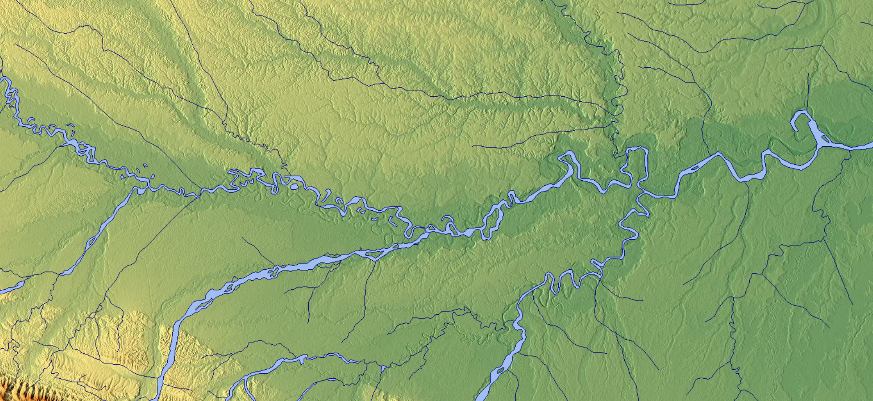
Figure 1. The caption heading for a figure should be placed below the figure and within figure/illustration width. (Use “Times New Roman” font, size 10pt, no spacing between title and figure)

Footnotes
Footnotes are denoted by a character superscript in the text b.

b Just like this one.

